Shrinkage correlation: AUDUSD and USDCAD
Method 08 / eight-major panel / delta = 0.2 and Ledoit-Wolf / Alpari D1 full available history

Study setup
Logical pair: AUDUSD , USDCAD
Broker symbols: AUDUSD_i , USDCAD_i
Snapshot: 2026-11-03_majors_alpari_D1
Timeframe: D1
Common eight-major panel window: 1999-01-06 to 2026-11-02 (UTC bar dates)
Panel matched return count n: 7127
Dropped unfinished last bar dated 2026-11-03 UTC after a tick-volume check against the prior complete day.
Fixed shrinkage: delta=0.2, mu=3.9170889e-05 (mean of diag(S))
Ledoit-Wolf estimated delta: 0.0042157642
Panel symbols: EURUSD, GBPUSD, AUDUSD, NZDUSD, USDJPY, USDCHF, USDCAD, EURGBP
Complete matched rows (Excel): AUDUSD-USDCAD_Shrinkage_D1.xlsx
Complete matched rows (HTML table): AUDUSD-USDCAD_Shrinkage_D1_data.html

Method carried forward
Shrinkage blends the sample covariance matrix S of matched daily log returns of close, ln(close_t / close_t-1), toward a simple target, then converts the shrunk covariance into correlations. Quotes are not inverted. This experiment builds one common calendar across all eight majors, forms S with the unbiased n-1 divisor, then reports two shrinkage specs: fixed delta = 0.2 with mu equal to the average sample variance (mu * I target), and sklearn Ledoit-Wolf with its estimated delta. Pair reports pull rho_ij from those panel matrices. Same-panel Pearson r is a side check only. Shrinkage improves conditioning; it is not a cause, not a lead, and not a trading signal.

Results
pearson_r | rho_02 | rho_LW | rho_02_minus_r | rho_LW_minus_r | delta_LW
-0.648925 | -0.51229 | -0.645966 | 0.136635 | 0.002959 | 0.00421576

Conclusion
Over the common 7127-day eight-major panel for AUDUSD and USDCAD (broker quote directions unchanged), fixed-delta shrinkage correlation at delta=0.2 is -0.5123 (negative, moderate linear link in this sample). Ledoit-Wolf rho is -0.6460 with estimated delta=0.004216. Same-panel Pearson r is -0.6489 (rho_02 minus r = 0.1366; rho_LW minus r = 0.0030). This does not establish cause, lead-lag, or a lasting trading rule.

Charts
Daily closes
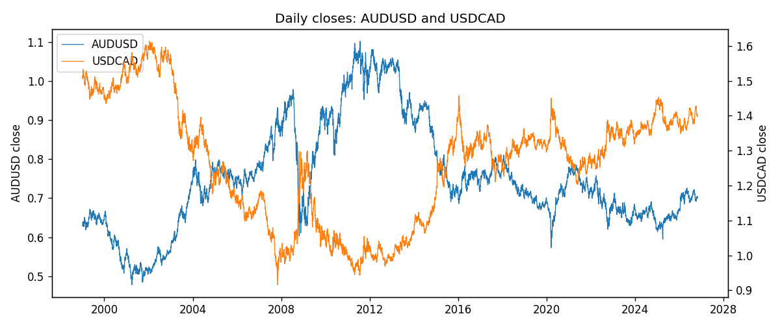
Daily log returns
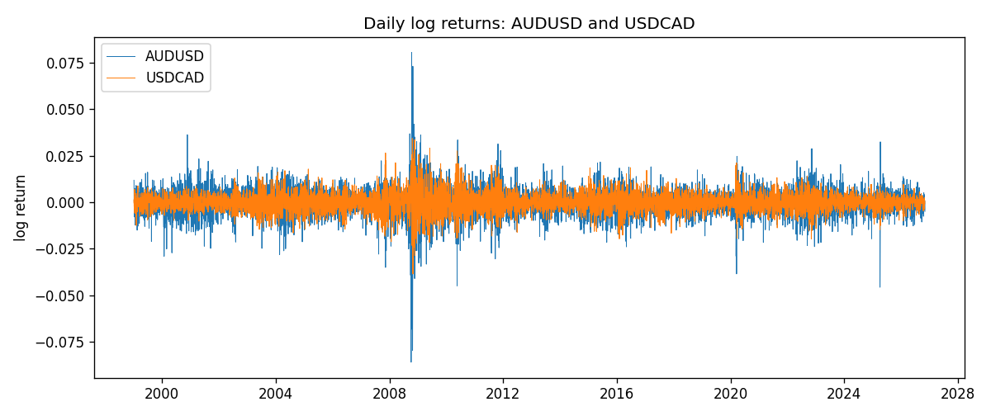
Log-return scatter
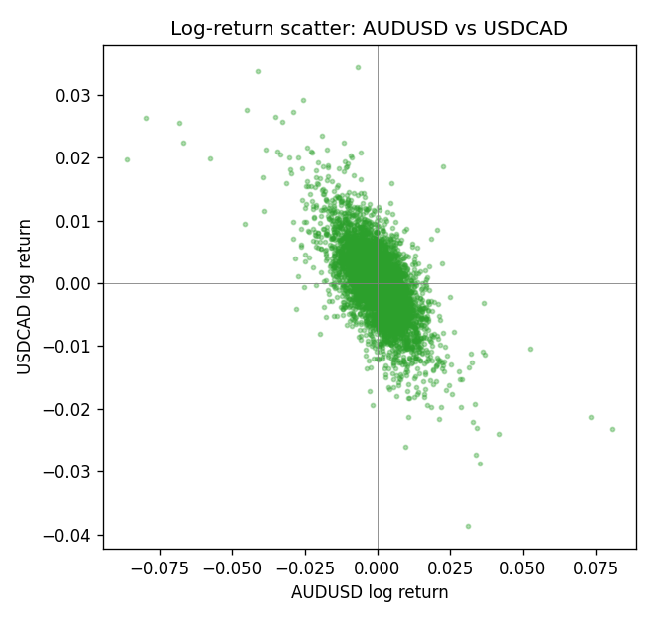

Data report
Every panel row for this pair slice is stored in the sibling Excel workbook named AUDUSD-USDCAD_Shrinkage_D1.xlsx. Full-panel covariance and correlation matrices are saved once under outputs/ as CSV files. Embedding all rows as a Word table is impractical at this length; the Word file holds the column list, column summaries, and the first and last 15 matched rows.
Columns: time, AUDUSD_open, AUDUSD_high, AUDUSD_low, AUDUSD_close, AUDUSD_tick_volume, AUDUSD_spread, AUDUSD_real_volume, AUDUSD_log_return, USDCAD_open, USDCAD_high, USDCAD_low, USDCAD_close, USDCAD_tick_volume, USDCAD_spread, USDCAD_real_volume, USDCAD_log_return
Column summaries (panel rows)
column | count | mean | std | min | 25% | 50% | 75% | max
AUDUSD_open | 7127 | 0.75283275 | 0.13531386 | 0.4785 | 0.66158 | 0.7319 | 0.812805 | 1.10284
AUDUSD_high | 7127 | 0.75689359 | 0.13587198 | 0.4878 | 0.66567 | 0.73555 | 0.8193 | 1.10795
AUDUSD_low | 7127 | 0.74877471 | 0.1346251 | 0.4775 | 0.65837 | 0.72811 | 0.80713 | 1.0975
AUDUSD_close | 7127 | 0.75288849 | 0.13529323 | 0.4786 | 0.661725 | 0.7321 | 0.812865 | 1.10169
AUDUSD_tick_volume | 7127 | 78106.737 | 138648.75 | 109 | 5647 | 44017 | 71744.5 | 1234623
AUDUSD_spread | 7127 | 30.658622 | 16.888951 | 0 | 13 | 30 | 50 | 50
AUDUSD_real_volume | 7127 | 5.2965195e+09 | 1.2602867e+11 | 0 | 0 | 0 | 0 | 3.811512e+12
AUDUSD_log_return | 7127 | 3.23e-05 | 0.0075548 | -0.08602525 | -0.00385041 | 0.00029027 | 0.00415332 | 0.0806166
USDCAD_open | 7127 | 1.2660158 | 0.16869092 | 0.9168 | 1.11698 | 1.29814 | 1.371685 | 1.6183
USDCAD_high | 7127 | 1.2709144 | 0.16864061 | 0.9336 | 1.122275 | 1.30368 | 1.37575 | 1.619
USDCAD_low | 7127 | 1.2614634 | 0.1687284 | 0.9056 | 1.112315 | 1.29315 | 1.36729 | 1.6102
USDCAD_close | 7127 | 1.2660395 | 0.16866578 | 0.916 | 1.116855 | 1.298 | 1.371955 | 1.6137
USDCAD_tick_volume | 7127 | 81672.889 | 147760.33 | 56 | 5669.5 | 41299 | 71973 | 1410818
USDCAD_spread | 7127 | 23.249895 | 18.19595 | 0 | 9 | 17 | 40 | 60
USDCAD_real_volume | 7127 | 1.8530805e+10 | 9.7086285e+10 | 0 | 0 | 0 | 0 | 2.5751613e+12
USDCAD_log_return | 7127 | -7.67e-06 | 0.00514753 | -0.03859748 | -0.0028338 | 5.597e-05 | 0.00272861 | 0.03436319
First 15 panel rows (selected columns)
time | AUDUSD_close | USDCAD_close | AUDUSD_log_return | USDCAD_log_return
1999-01-06 | 0.6289 | 1.5118 | 0.011836351 | -0.0003306769
1999-01-07 | 0.6345 | 1.5141 | 0.0088650256 | 0.0015202092
1999-01-08 | 0.6347 | 1.511 | 0.00031515916 | -0.0020495197
1999-01-11 | 0.6393 | 1.5057 | 0.0072213815 | -0.0035137769
1999-01-12 | 0.6362 | 1.5157 | -0.0048608485 | 0.0066194721
1999-01-13 | 0.6312 | 1.5226 | -0.0078902098 | 0.0045420214
1999-01-14 | 0.6295 | 1.5332 | -0.002696916 | 0.0069376546
1999-01-15 | 0.634 | 1.5245 | 0.007123101 | -0.0056905671
1999-01-18 | 0.6346 | 1.526 | 0.00094592471 | 0.00098344542
1999-01-19 | 0.6392 | 1.5302 | 0.0072225153 | 0.002748513
1999-01-20 | 0.64 | 1.5211 | 0.0012507819 | -0.0059646885
1999-01-21 | 0.6405 | 1.5146 | 0.00078094498 | -0.0042823796
1999-01-22 | 0.6327 | 1.5184 | -0.012252745 | 0.0025057712
1999-01-25 | 0.6302 | 1.5197 | -0.0039591468 | 0.00085579808
1999-01-26 | 0.6305 | 1.52 | 0.00047592608 | 0.0001973879
Last 15 panel rows (selected columns)
time | AUDUSD_close | USDCAD_close | AUDUSD_log_return | USDCAD_log_return
2026-10-13 | 0.69821 | 1.4214 | 0.0035007712 | -0.0046395653
2026-10-14 | 0.69715 | 1.42356 | -0.0015193215 | 0.0015184751
2026-10-15 | 0.69191 | 1.41843 | -0.0075447063 | -0.0036101503
2026-10-16 | 0.69426 | 1.41357 | 0.0033906408 | -0.0034322068
2026-10-19 | 0.6978 | 1.41091 | 0.0050859986 | -0.0018835331
2026-10-20 | 0.70022 | 1.40569 | 0.0034620426 | -0.0037066008
2026-10-21 | 0.70275 | 1.4045 | 0.0036066384 | -0.00084691787
2026-10-22 | 0.70186 | 1.40081 | -0.0012672558 | -0.0026307268
2026-10-23 | 0.70353 | 1.40085 | 0.0023765656 | 2.85545e-05
2026-10-26 | 0.70128 | 1.40093 | -0.0032032829 | 5.7106554e-05
2026-10-27 | 0.70245 | 1.40449 | 0.0016669876 | 0.0025379458
2026-10-28 | 0.70533 | 1.39911 | 0.0040915541 | -0.0038379274
2026-10-29 | 0.70245 | 1.39895 | -0.0040915541 | -0.00011436495
2026-10-30 | 0.70316 | 1.39751 | 0.0010102376 | -0.0010298736
2026-11-02 | 0.69971 | 1.39837 | -0.0049184984 | 0.00061519094

